Project Design Phase-II

**Data Flow Diagram & User Stories**

|  |  |
| --- | --- |
| Date | 17 OCTOBER 2022 |
| Team ID | **PNT2022TMID27338** |
| Project Name | **Project - Natural Disasters Intensity Analysis and Classification using**  **Artificial**  **Intelligence** |
| Maximum Marks | 4 Marks |

**Data Flow Diagrams:**

A Data Flow Diagram (DFD) is a traditional visual representation of the information flows within a system. A neat and clear DFD can depict the right amount of the system requirement graphically. It shows how data enters and leaves the system, what changes the information, and where data is stored.

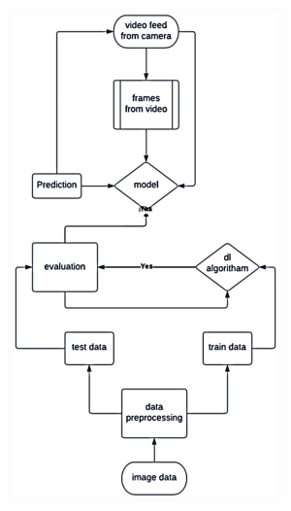**Example:**

**User Stories**

Use the below template to list all the user stories for the product.

|  |  |  |  |  |  |  |
| --- | --- | --- | --- | --- | --- | --- |
| **User Type** | **Functional Requirement (Epic)** | **User Story Number** | **User Story / Task** | **Acceptance criteria** | **Priority** | **Release** |
| Customer | Installation | USN-1 | As a user, I can install this where the disaster occur | I can do it by myself | High | Sprint-1 |
| Customer | Power connection | USN-2 | As a user, I want ensure power supply for all devices | I will ensure it | High | Sprint-2 |
| Customer | Safety | USN-3 | As a user, I want to ensure that the device should be in safest place which covers the maximum area | I will ensure that | High | Sprint-3 |
| Customer | Battery backup | USN-4 | As a user, I want check the batter backup to prevent it from power loss | I can assure that | High | Sprint-4 |
| Customer | Internet Connectivity | USN-5 | As a user, I want to check the internet connectivity | I will ensure that | High | Sprint-5 |